TRANSPARENCY AND INTEGRITY OF PUBLIC ADMINISTRATION
(THE PHENOMENON OF CORRUPTION AND ITS PERCEPTION)

Jr. Lecturer Mihaela CĂRĂUŞAN

ABSTRACT: The transparency and integrity of public administration is a major condition for Romania’s passing from a totalitarian regime to democracy and prosperity and for its integration in the economic, political and security systems of the Euro-Atlantic community. There is a unanimous consensus as far as this necessity is concerned in the Romanian society.
Despite all this, the lack of transparency and the corruption in public administration structures have constantly affected Romania’s economic, social and political developments and its relation with the European and Atlantic institutions, as well as its possibility of integration in these structures. The last years have been characterized by a severe worsening of the situation and the most recent internal evaluations, as well as those made by international institutions, strengthen this conclusion.
In terms of international undertakings, Romania ‘has been very active’, signed and in some cases already ratified various treaties on the fight against corruption and organized crime, and has played an active role in implementing several evaluation programmes. Domestically, these efforts have resulted in the introduction of a relatively extensive, and comprehensive, legislative framework, providing the authorities responsible for preventing and fighting corruption with a number of effective tools to conduct their tasks.
Nonetheless, despite the clear willingness of the Romanian authorities to eliminate corruption, the phenomenon of corruption in Romanian daily life is undeniable. Corruption is the scourge, which increases the poverty and the weaknesses of the State. The phenomenon of corruption is an intrinsic one, which is bound to the moral climate of the society and we must admit that societies in transition (such Romania), are more vulnerable than others.
When we analyse corruption in underdeveloped countries we have to take into account the formal and also the informal institutions. For example, an anti-corruption act will make little sense in a legal culture in which no law is enforced and nobody collaborates with the police, as is the case of Romania. A mass education programme risks having no effect at all as long as attributing bad intentions to the government and considering the whole political class a band of thieves at the expense of ordinary citizens is a general belief.
The undoubted reality of corruption offences in Romania is all the more worrying by the fact that the institutions most involved in fighting corruption, namely the police and the justice system, are also affected by the phenomenon. This distrust of citizens certainly represents an obstacle to the success of the measures adopted to prevent and fight corruption.
WHAT IS CORRUPTION?
In Romania, people answer to such a question in different ways, because they see the phenomenon as:
- an abnormal activity that is completed by different persons which occupy a top level position at a time being – when the corrupter needed to accomplish/obtain an economical, administrative and juridical advantage; in change of an amount of money or other gifts;
- the use of his own job or public position, to elude or avoid accomplishing standards or legal provisions, with the goal to obtain material advantages or a better job.
Corruption is perceived as a real enemy of democracy, for legality and for social and judicial equity, destroys the principle of an efficient administration, wearing down the free market concept and puts in danger the stability of the State institutions.
Corruption is rife and all pervasive, though many allegations are nothing but political intrigue. Luckily, in countries such as Romania, it is confined to its rapacious elites: its politicians, managers, medical doctors, judges, journalists, and top bureaucrats. The police and customs officials are hopelessly compromised.
However, behind the screens it has always been there, referred to as the ‘c-word’, the word that make problems to the government.
Almost ten years ago research and concern on corruption was a small field. Currently, however, a large number of editorials, surveys and reports are published every week and month. This development partly reflects an increased public concern for the problem.
Generally speaking, and theoretically, it is recognized that the governments in poor countries are also the most corrupted. This is one of the few clear empirical results of recent research, studies on corruption. As far as Romania is concerned, we cannot say that it is a poor country, it is only a country that tries to make the transfer from the absolutism to a market economy. In this transfer different stakeholders are present in the government life and the vice-versa.
Corruption, as we know already, is a complex and multifaceted phenomenon with multiple causes and effects, as it takes various forms and functions in different contexts. The phenomenon of corruption ranges from the single act of a payment forbidden by law to an endemic malfunction of a political and economic system. The problem of corruption is seen either as a structural problem of politics or economics, or as a cultural and individual moral problem. The definition of corruption consequently ranges from the broad terms of ‘misuse of public power’ and ‘moral decay’ to strict legal definitions of corruption as an act of bribery involving a public servant and a transfer of tangible resources.

Figure 1. Figure 2.

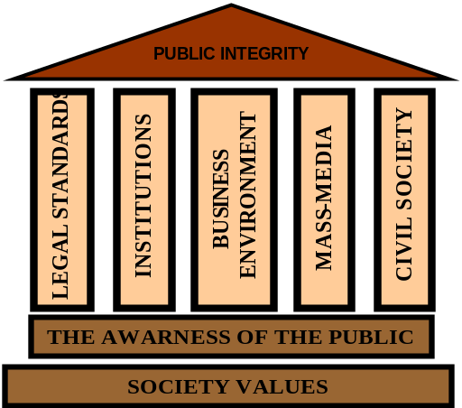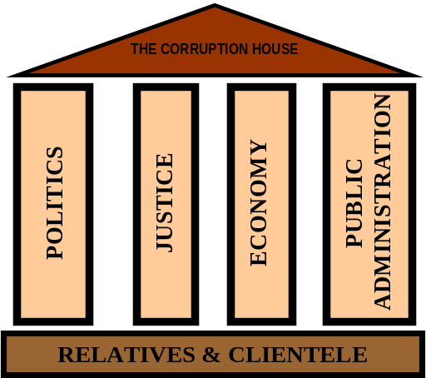

The Romanian social values have suffered many changes after the transfer of power (1989) and the public awareness in the first decade was very low. The culture was different; we are now in the situation to find and to discover other cultures, for the first time we find out about the political culture and the administrative one.
The Romanians concerns were not to see what happens beyond their own interests, and if a false moral conduct will later on cause a ruin in the public integrity house (see Figure 1). From this ruins the society was able to build another level, another house that was easy to be built but it is not so easy to be knocked down, the corruption house (see Figure 2). The moral conduct of the society takes us under the sign of corruption.
Corruption understood in this broader term has been called ‘social exchange’ and social corruption. Social corruption is conventionally understood as an integrated element of clientelism. Clientelism often implies an exchange of material benefits but cannot be reduced to this, because clientelism has a wider cultural and social implication. The movement was not made directly, we started from what it seems to be later contagious, the use of family and relatives relation; in our point of view this take us to the clientelism and so on to the other forms of corruption. Clientelism, nepotism, ethnic and other favouritism are all altrernatives of corruption, in social terms.
Not only once, we heard that the Romanian mentality has its fault in this negative movement. Romanians are used to pay their civil services twice, even not at the same value (bunches of flowers, package of cigarettes etc.). All of these were not possible if the legal standards, the institutions, the business environment, the media and more important, the civil society did not indulge in this state of facts.
The four pillars that were called to support the house of corruption were the result of the diminished importance of the public integrity, and, more important, of the public trust in the State and in its institutions. Consequently the politicians, the justice, the public administration and the economy, for which the first three actors were called to make the privatization, have suffered the influence of the phenomenon and even worse, they creates some forms of the phenomenon.
Starting with the year 2000, Romania passes from the denial of the phenomenon to the acceptation – the period in which we are for the moment, but we are looking to the future, to the moment when we will minimize this scourge.
DENIAL
ACKNOWLEDGEMENT
DIMINISHING

LAW
INSTITUTIONS

MEASURES

What it is the present state of facts, we shall try to present in the following lines.
Given a definition of corruption as a particular State-society relationship, the roots of corruption is consequently found at the two fields of interaction between the State and the society behind it, namely at the national and the international level. Besides, it takes place within the State itself, between its various layers or levels.
After 2000, at the political level starts a real contest for the promotion of different legal provisions (24 Acts, out of which the most important is the National Law Package Anti- Corruption, 2003), at present we can say that we have the law, and even more, we have created the institutions that have to fight corruption (National Authority for Control, National Prosecutor Office Against Corruption, The Government Control Department, The National Committee for Preventing Criminality, The National Office for Witnesses Protection). As for the performance of these institutions, we shall see in the last chapter of this paper.

ROMANIAN FORMS OF CORRUPTION
At the level of home institutions, i.e. within the various levels and agencies of the State, corruption takes its place between the different structures of the State (like the Executive, Legislative and Juridical structures), and between the political and administrative/bureaucratic institutions (the civil service, local authorities and other authorities). These relationships can be corrupted because of overlapping and conflicting authority, political power-struggles (see Figure 4) over access to scarce resources, manipulated flows of information, and personal relationships of dependence and loyalty. In particular, a weak separation between civil service and party politics, a poor professionalism of the bureaucracy, a lack of administrative accountability and transparency, and poor political control and auditing mechanisms will increase corruption at these points. The more discretion officials obtain on abundant, complex and non-transparent regulations, the more probable corruption becomes.

Figure 4.
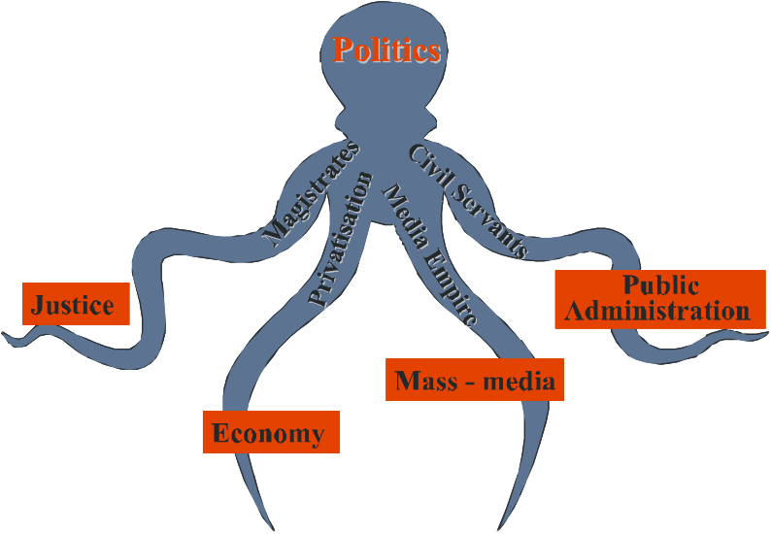
At the national level, corruption occures at the meeting point between the State institutions and the various stakeholders. On the one side there is the corrupted State official; on the other side there is the supplier of bribes, i.e., the one who corrupts. The officials can be anyone from the President and top political leadership (political corruption) down through the hierarchy (bureaucratic corruption) to the most remoted local government public servant. The many possible non-State counterparts include the general public, any non-governmental and non-public persons, corporation or organisation. Here, corruption is one of the mechanisms through which the authoritarian power-holders are gathering fortunes. Graft and rent-seeking are not diseases that the responsible politicians are eager to avoid, but a deliberately applied practice.
Many theories and research studies on corruption call attention to the ‘corrupters’, those who offer the bribes in the first place, and the advantages they gain. Other theories emphasise the corrupted people and their advantages. We cannot study, from the Romanian point of view, only one of them, because both theories are important and for us they have a connection line which connects them.
Corruption, however, also exists within and between private businesses and within non-governmental organisations, without any State agency or State official being involved. There is corruption in terms of bribing, swindling and mafia-type methods in businesses, and there are disloyal employees in private firms, non-governmental organisations and associations.
But it is also widely accepted as a fact that corrupted host-countries are sometimes particularly attractive for certain businesses located abroad. However, international actors (in business, politics and development co-operation), there can be at the same time possible corrupters and reform supporters (we can see in this way the privatisation of many Romanian national companies such as ROMTELECOM and SIDEX).
Besides, corruption also exists as a moral and cultural problem in society, among individuals in their personal dealings. Accepted and expected practices of gift-giving, tipping and patronage exist in most societies, even when such practices are illegal. These practices impose hidden costs on public services and/or confuse the distinction between public and private, and also foster psychological corruption.
Besides, all forms of ‘private’ corruption can be destructive to the public morale and undermine the general trust and confidence in rules and regulations. However, most cases of corruption emphasise corruption as a State-society relationship because public sector corruption is believed to be a more fundamental problem than private sector corruption, and because controlling public sector corruption is a prerequisite for controlling private sector corruption. We can go on saying that controlling petty corruption is a prerequisite for controlling grand corruption.
Grand corruption takes place at the highest level of political authority, maybe this is way is also called the political corruption. Those who are called to develop anti-corruption strategies, the policy-makers, are in fact those who are corrupted.
Public administration and its civil servants as policy implementers are called in to implement practice the legal standards, but they can also be influenced of the phenomenon either directly, from the different stakeholders or indirectly through politicians (local and central). Likewise, bureaucratic corruption may occur at the end of implementation of public administration without necessarily being a part of the political system or having political repercussions. Taking into consideration this we see why the political corruption is different from the bureaucratic corruption which it is petty, and which appear at the end of politics. (Figure 5)
The activity carried on by civil servants requires a balance the different specialisations. In Romania it is well known that if you are engineer you can find a place in public administration and if you are specialised in public administration the private sector awaits for you. This discrepancy was created and as we can see in Table 1 the civil servants that are specialised in public administration had only a percent of 0.76. As for the bureaucratic corruption, we wonder if is so, a negative result of this table, split of professions, if it is than why we blame civil society and not the authorities? Anyhow, we can conclude that the knowledge that you obtain as engineer are better used in public administration authorities than the one in administrative science.

Figure 5
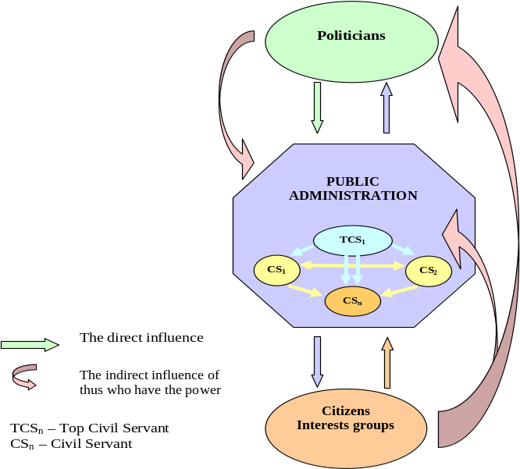

Table 1
Crt.No. | Profession | No. of civil servants
 | Engineers | 18816
 | Economists | 17537
 | Lawyers | 4268
 | Professors | 3279
 | Vets | 1849
 | Medical Doctors | 626
 | Specialised in Public administration | 406
 | Sociologists and psychologists | 223
 | Social workers | 94
 | Others | 6304
Figure 6

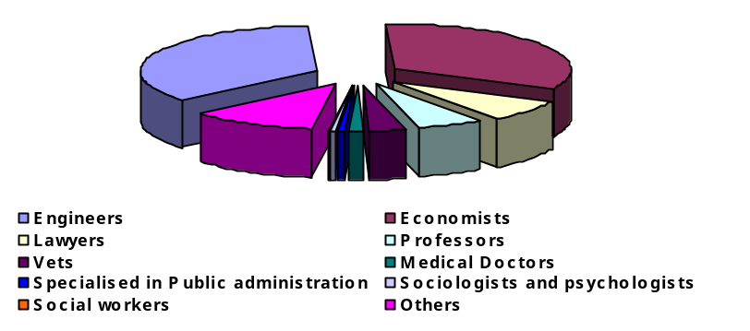

As one high official recognised it, in Romania we have a so called positive corruption, which represents the act of bribery, but occurring in special circumstances – the corrupter (the one who gives) offers a bribe and the corrupted does the thing (does something or not) he was paid for. The other side is seen as negative corruption – when the corrupter was paid but he doesn’t do the thing he promised he would do, he changes his mind, but he keeps the bribe.
Legally, are recognised as forms of corruption: bribery, embezzlement, fraud, extortion, favouritism, power excess, and so on.
We also can classify corrupted behaviours according to their outcomes:
- income increase - corrupt actions whose sole outcome is the supplementing of the income of the provider without affecting the ‘real world’;
- information altering fees - bribes that subvert the flow of true and complete information within a society or an economic unit (for instance, by selling professional diplomas, certificates, or permits);
- acceleration or facilitation price - corrupted practices, whose sole outcome is to accelerate or facilitate decision making, the supply of goods and services or the leaking of information;
- changing fees – pay-offs and promises of pay-offs which modify decisions or affect them, or which affect the decision-making of policies, laws, regulations, or decrees, to the advantage of the bribing entity or person;
- re-allocation fees - pay-offs paid (mainly to politicians and political decision makers) in order to change the allocation of economic resources and material wealth or the rights of veto (concessions, licenses, permits, privatised assets).
The interests of those who are corrupted, as we could see it, are different, everyone trying to obtain as much as they can from the position they hold. This is way we must make the difference between the ‘street’ corruption and the political one. The so called street-corruption can occur at the lower civil servants level and has as outcomes the first two consequences: political corruption is present in the case of top officials and political levels and has as outcomes the third respectively the last two of them.

PUBLIC PERCEPTION
As noted, the public perception is very important because it shows us if the public confidence, more in some institutions and less in others. In Romania, for example, in the last few years the public perception over the judicial and public administration system is low (according to WB, TI and other institutions). Romanian judges and civil servants admitted that there is an ‘authority problem’ faced by the judiciary and public administration. Maybe what is more important is that the public also lacks knowledge and information about the status and duties of a judge and of a civil servant. Civil society activism is crucial; NGOs, and others, with significant democratic voice have to be more involved.
Transparency is the main weapon against corruption. The expression says that sunshine is the best decontaminator. Public procurement on the web, town hall meetings, discussing openly the budget of the city, and large procurement projects, discussing the rules of the game for such procurements, and who are, plenty of information, full access to information, is critical for transparency. In this context, the main tool of information – the Internet, can play an extremely important role. Within transparency, and within voice and accountability, but certainly within the freedom of the press corruption can not be eradicated.
Taking into consideration all these issues, new information, on data, on surveys, and other types of initiatives where data is highlighted on vulnerable institutions, about corruption, is an enormously important check and balance in this context.
High-trust societies are often associated with lower levels of corruption. This holds true only for generalized trust, i.e. trust in anonymous and institutions. The opposite is true for specific trust, i.e. trust which is a person or a situation. We will study in this paper only the first form of trust because the second is much wider, and because the first produce the negative effect over the perception indicator used at national and international level.
Making a study over the TI scores as far as Romania is concerned we will see that corruption is worse and more widely spread at the State structures level. As Romanians like to compare in everything they do with Bulgaria and Hungary, we made the same comparison study over the TI – CPI Score, since 1997 to 2003 (Table 2, Figure 7). What is shown in the study worry us, if Bulgaria starts with a perception indicator lower (more corrupt) than Romania, now we are in the situation to see that Romania has become more corrupted and did not make any change in this direction. It also true that Romania has started the real fight against corruption in 2003 and the performances can only be seen in 2004. But, the CPI shows us that even if the institutions take measures in this direction, still society perceive corruption as having a at high level. Beside the TI indicators, a Romanian survey (Figure 8) shows us that, even after 2003 population perceived corruption as very high – two thirds (2/3) of the population.
Table 2
Year | Place | CPI  Score | Surveys  Used | Deviation
1997 | 37 | 3.44 | 4 | 0.07
1998 | 61 | 3.0 | 3 | 1.5
1999 | 63 | 3.3 | 6 | 1.0
2000 | 68 | 2.9 | 4 | 1.0
2001 | 69 | 2.8 | 5 | 0.5
2002 | 77 | 2.6 | 7 | 0.8
2003 | 83 | 2.8 | 12 | 1.0

Figure 7
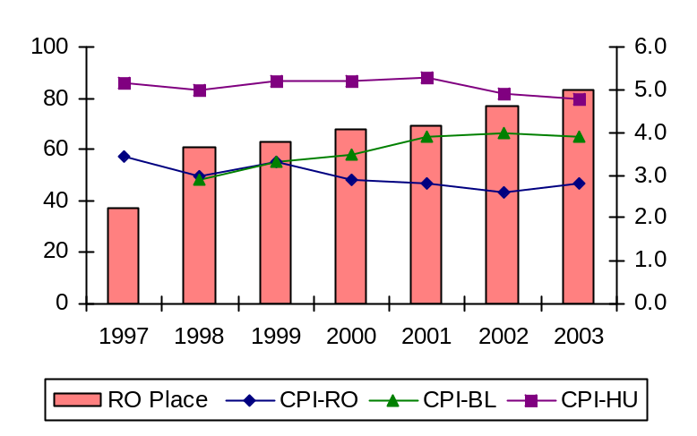
Figure 8
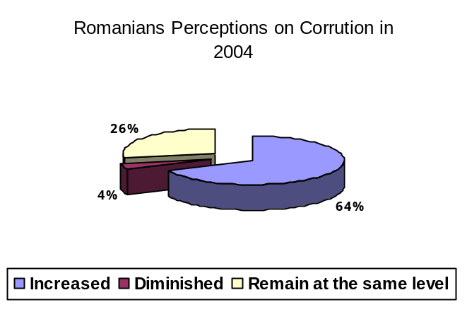

MEASURES TAKEN
In order to suppress corruption, one must deal with both giver and taker.
The strongest remedy against corruption is sunshine - free, accessible, and available information disseminated, and proved by an active opposition, uncompromised press, and assertive civic organizations and NGO's. In the absence of these, the fight against official avarice and criminality is doomed to failure.
Corruption can never be entirely suppressed - but it can be confined and its effects minimized. The cooperation between correct people and trustworthy institutions is indispensable. Corruption can be defeated only from the inside, though with plenty of outside help. It is a process of self-transformation. It is the real transition.
Yet, corruption is not a monolithic practice. Nor are its outcomes universally deplorable or damaging. The moral relativism has taught us that ‘right’ and ‘wrong’ are flexible, context dependent and culture-sensitive yardsticks.
Romanian has now the possibility to diminish the system crisis and go further and should not go back, throwing the responsibilities on the previous government shoulders – something that is happening every time when a political mandate is over, and another one is beginning. But not only the political level has to be changed in his mentality, also the society which, as the practice shows, for every written act/standard, invents another 100 unwritten acts.
The most current measures taken against corruption are the ones undertaken by the National Prosecutor Office Against Corruption (NPOAC). The NPOAC started its activity in September 2002, beginning with this date, this institution is perceived as the major fighter against corruption. But, it is also true that its major concern was to fight against petty corruption, even if the public desire is to see a few cases that are part of the grand corruption.
As compared with the activity that was carried out until its creation by the Ministry of Justice, the National Prosecutor Office and other institutions; measures are thirteen times more effective, with respect to corruption at managerial level – medium level corruption.
Figure 9
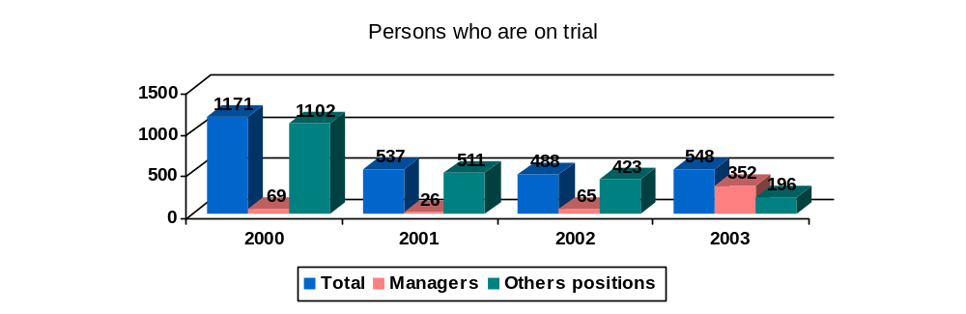
These 548 persons in current trials are the authors of almost 1428 corrupt offences, as they are presented in the Figure 10.
Figure 10
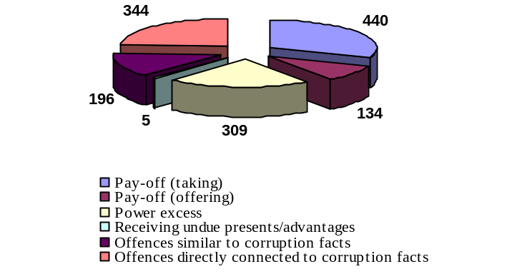

CONCLUSION
Corruption is the agent that often undermines the importance of formal institutions in strengthening of democracy and good governance. There are strong arguments and evidence that well-functioning legal, administrative and institutional institutions are necessary requirements for development. However, research studies on corruption look beyond the formal structures of the central State, to the informal networks of patronage and social domination that often bring about a wild behavior of political factors, including at local community or district level. The material links between the State institutions and society ought to be proven, and to explore the multiple ways in which they influence and model each other. Weight should also be given to the legacy of historical antecedents, including the legacy of totalitarian regimes.
Although institutions may have traditional and patrimonial functions in addition to their formal roles, citizens do relate to and are dependent on the formal institutions (constitutions, electoral planning, party systems, legal orders, and administrative procedures) to gain their full and basic political and civil rights. In particular, when it comes to democratic consolidation, there is a question of the spread of democratic standards, of political skills, and the creation of political institutions. Thus, the research focused on both informal and formal institutions.
Anti-corruption strategy as far as Romania concerned has to be as WB shows in his ‘multipronged’ strategy. For the time being the implementation of anti-corruption strategies will need a focus on public agencies.
Figure 11
The World Bank’s ‘multipronged’ anti-corruption strategy
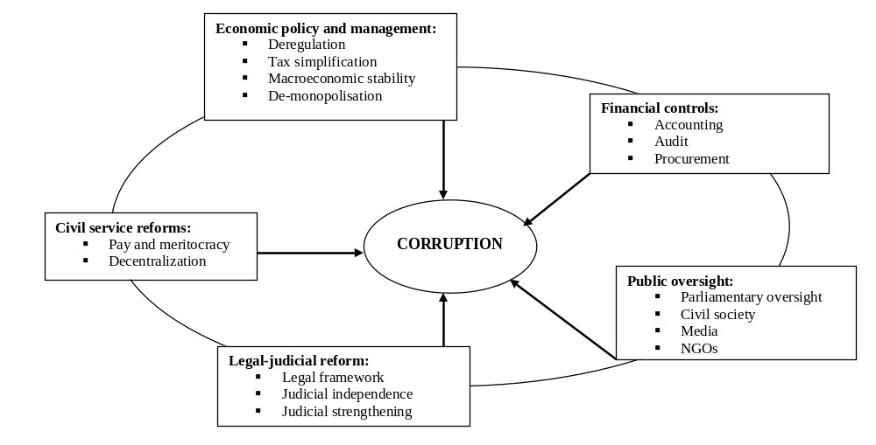

REFERENCES
Jens Chr. Andvig and Odd-Helge Fjeldstad, Inge Amundsen, Tone Sissener, Tina Søreide, Research on corruption a policy oriented survey, NORAD, 2000.
Jeremy Pope, Public Integrity System, TI, 2002.
National Prosecutor Office Against Corruption, 2003 Report, http://www.pna.ro.
National Agency of Civil Servants, 2003 Report.
Transparency International: “Corruption perception index 1997-2003”, http://www.transparency.org.
Romanian Academic Society (SAR), http://www.sar.org.ro.
World Bank, http://www.worldbank.org

The National School of Political Studies and Public Administration, Faculty of Public Administration, Bucharest, Romania.
Source: Jeremy Pope, Public Integrity System, TI, 2002, p. 118.
Médard, Jean-François (1998): ‘Postface’ in Le Clientélisme Politique dans les Sociétés Contemporaines. Briquet and Sawicki, eds, Paris: Presses Universitaires de France. Chapter 11, pp. 308.
To see in this way the Romanian Transparency International Report, 2004.
National Agency of Civil Servants, 2003 Report, p. 37.
Carried out by the Romanian Academic Society (SAR).
World Bank, 2000.

